|  |
| --- |
|  |



**12 April 2013** **The Weekly Bulletin of Rotary Club of Kathmandu Mid-Town** **Bc-12.4/012-13**

**District : 3292 Web: www.rotarymidtown.org.np Club Id : 26776**

**APRIL IS MAGAZINE MONTH**

Rotary International today claims a unique communications network — The Rotarian, the official English language magazine of Rotary International and 31 Rotary World Magazine Press magazines that are independently produced in their countries across the globe. They are published in more than 20 different languages, distributed in 132 countries, and have a combined circulation of 769,000.

Friday, 5 April:

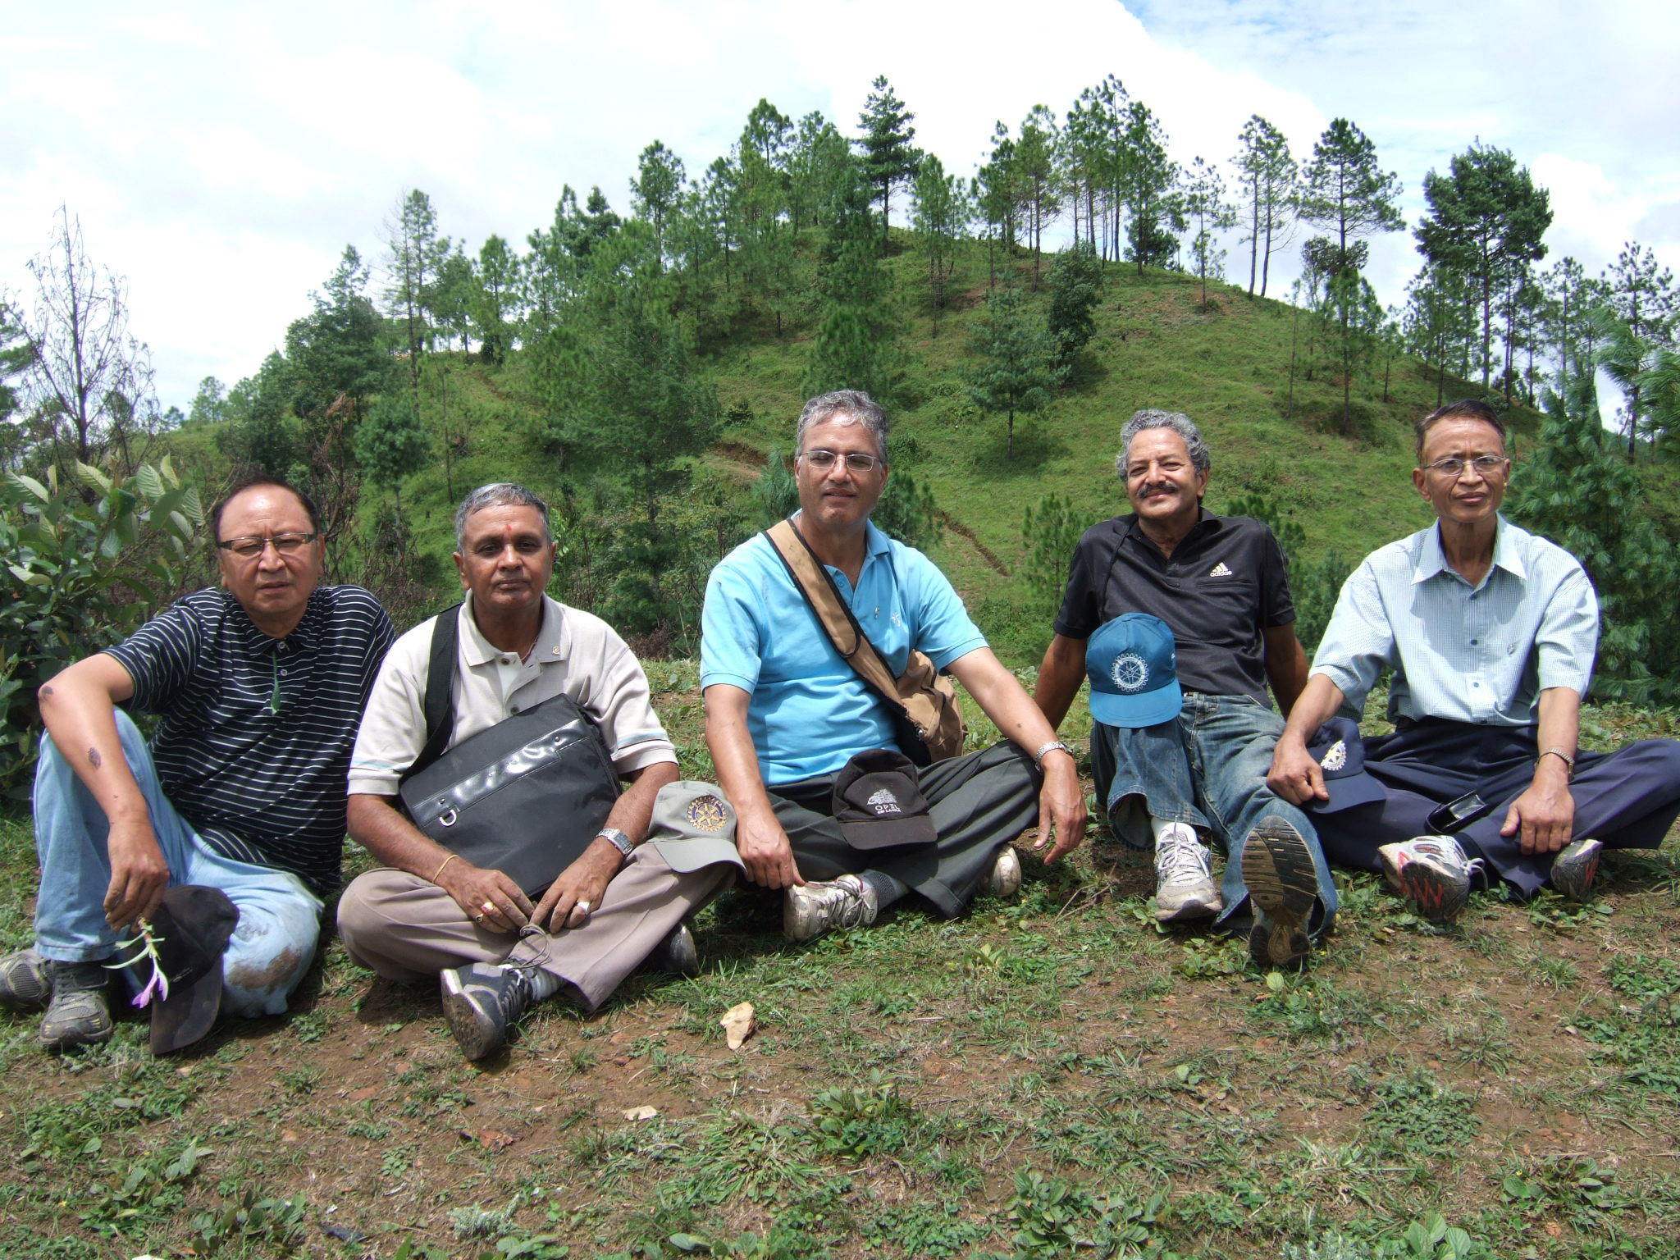

It was a sad day for the Club. Before starting the meeting President Devendra announced

that PP Pratap Malla, a very active member of the Club, expired yesterday, Thursday, 4th

April 2013. Then he called the meeting to order. Instead of usual 30 seconds silence,

President Devendra proposed and every one present stood in silence for one minute to

pay homage to late Pratap.

Mid-Towners remembered and shared Pratap's contributions in Rotary, his dedication to

the purpose, involvement in service projects, type of person he was : very active, selfless service, sincerity towards commitments, self-driving so on and on.

**Tribute to late Rtn Pratap Malla**

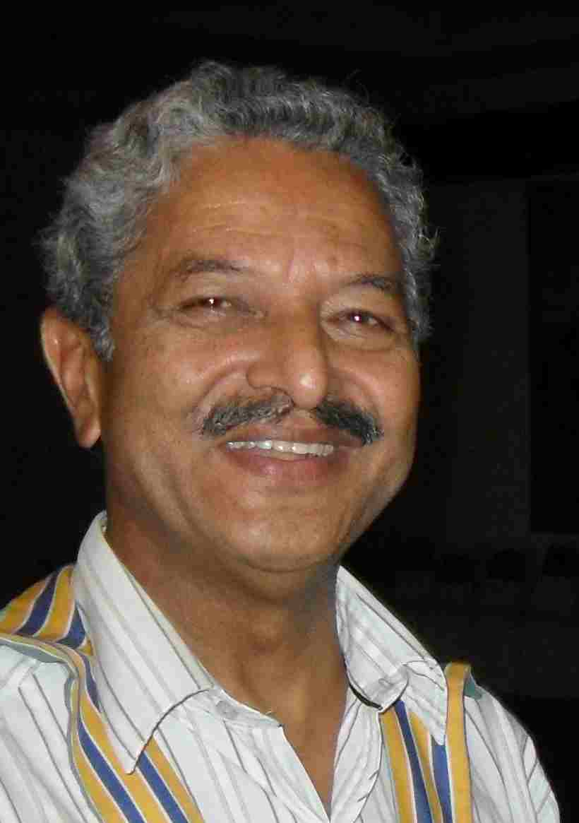

**Rtn Pratap is no more with us.**

**He was a dedicated, a very committed and self-inspired Rotarian.**

**It's an irreparable loss for Nepal Rotary in general and**

**for the Rotary Club of Kathmandu Mid-Town in particular.**

**Heart-felt Condolences to his bereaved family.**

**Condolence messages:**

President Devendra received condolence message from Rotarians all over on sad news of demise of Rtn Pratap Malla. Everyone who received the news was shocked, saddened and immediately responded by sending condolence message to the bereaved family and praying Almighty peace for the departed soul.

Condolence message received so far from:

Colin, RC Capitol Washington, USA

Rtn. Jagan Gurung, PP RC Pokhara

Ramesh Chitrakar, IPP, RC Chandragiri

Jayanta Berma, President  2012-13, RC of Kathmandu North East,

Rtn. Dr. Badri raj, Past President, RC Budhanilkantha,

Rajendra Subedi, President, RC Rupandehi,

Prakash Man Pradhan, PP RC Rajdhani

Vishnu B. Karkee, RC Baneshwor

Rtn Janak Prakash Thapa, President, Rotary Club of Patan Durbar Square

PP Hari Om Shrestha, RC Patan West

Chandi Shrestha, RC Lalitpur Mid Town

KB and Usha Chettry, RC New Road City

Rotary club of Kasthamandap family

Rtn.Govind Singh(Lucky Singh), AG-Zone-XVI 2012-13

Pratap Pradhan, President RC Chandragiri

Major Yambahadur Gurung, PP RC The HImalayan Gurkhas

Er. Dhruba Thapa, President, Rotary Club of Kantipur

Badan, PP RC Mount Everest

MADAN, President RC Tripureshwor

Rtn Beni Gopal Mundara, RC Biratnagar

Maurizio Montanari, RC Ravenna and Remo di Carlo, President, Rotary Club of Ravenna

Pradeep, RC Rajdhani

PP Timsina, RC Dillibazar

Condolence phone call from Rtn. Rajesh Thapa, Chair DCRF, Rtn. Maheshwar Bhakta Shrestha, Chair, District Publication Committee (GML), Rtn. Rajendra Subedi, President RC Rupandehi, Ms. Vidya Vaidya, Director ERC Lalitpur.

# Weekly Meetings and Programs :

|  |  |  |
| --- | --- | --- |
| Date | Program/Speaker | Program/Topics of Presentation |
| 12 April 2013 | Club assembly | Club assembly |
|  |  |  |

Friday, 12 April:

The 4th Club Assembly will be conducted by AG Jeevan L Amatya. All permanent committee chairs will submit and discuss on progress review and activity reportings.

**PETS :**

The President-Elect Training Seminar 2013 (PETS) was held for two days at Butwal on 30 and 31 March 2013. President-Elect Rtn Saroj Shrestha took part in the Seminar. Besides President-Elect Saroj three other Mid-Towners including DG Yogendra Pradhan,attended the Seminar - PP Mani Joshi and PP Komal Chitrakar as the resource personnel.

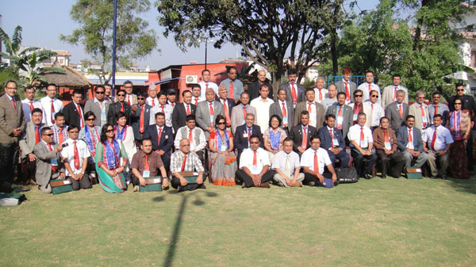

Group photo: District Governor-Elect Dilendra with President-Elects

In Japanese the word *ichiban* means to be the best. … and for me, Rotary service means

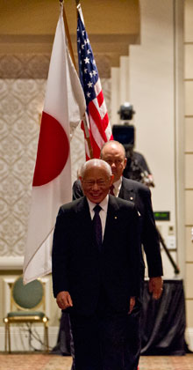

being *ichiban*. It means doing your best, and being the best you can be. It means working as

hard as you can – not for yourself, but for others. It means achieving as much as you can, to

make other people’s lives better.

**RI President Sakuji Tanaka**

Happy New Year 2070 :

Click here ⇩



A thought for the day:

***In order that people may be happy in their work, these three things are needed:***

***they must be fit for it;***

***they must not do too much of it;***

***and they must have a sense of success in it.***

*John Ruskin*

*courtesy:* Rtn Dr Isabella C Bassingana Khadka

Great quotes:

***Instead of thinking about 'How to Win',***

***think how you 'Lost Last Time',***

***you will definitely Win Next Time !***

Number game:

If 1 ÷ 3 = 0.333333333333….

? ÷ ? = 0.777777777777….

NB: Send any informations/photos that may be of interest to the Club or Rotarians in general to

BC Editor: RR Shrestha email: rryesrr@gmail.com

## 12 April 2013 The Weekly Bulletin of Rotary Club of Kathmandu Mid-Town bc-12.4/012-13